SRE Submission

Build a custom container

Dockerfile
ARG NEXUS_VERSION=3.68.1
FROM sonatype/nexus3:${NEXUS_VERSION}

ARG PLUGIN_VERSION=0.61.0
ARG BUNDLE_NAME=nexus-blobstore-google-cloud-${PLUGIN_VERSION}-bundle.kar
ARG KAR_URL=https://repo1.maven.org/maven2/org/sonatype/nexus/plugins/nexus-blobstore-google-cloud/${PLUGIN_VERSION}/${BUNDLE_NAME}

USER root
ADD --chown=nexus:nexus ${KAR_URL} /opt/sonatype/nexus/deploy/

USER nexus

Create Container in local laptop for testing
docker run -d \
-p 8081:8081 \
--name my-nexus \
-v ./gcp-service-account.json:/opt/sonatype/nexus/etc/gcp-creds.json \
-e GOOGLE_APPLICATION_CREDENTIALS=/opt/sonatype/nexus/etc/gcp-creds.json \
nexus3-gcs:3.68.1

1.3 Get default password admin
docker exec my-nexus cat /nexus-data/admin.password

Create service account
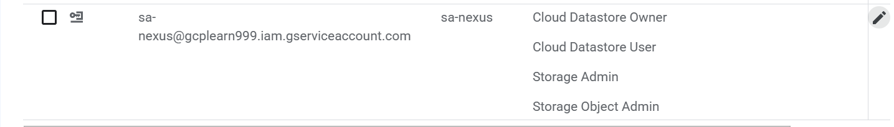

Cloud storage - bucket

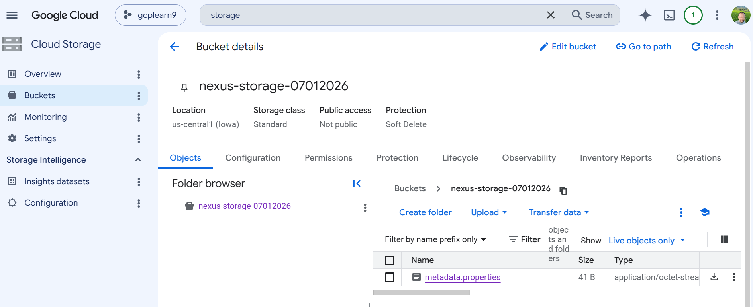

1.6 Create Nexus Blob Store
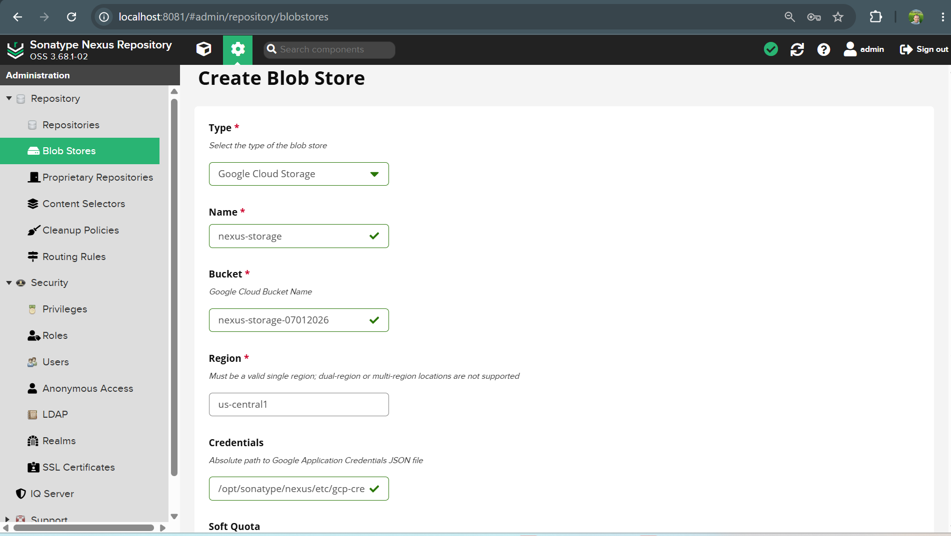

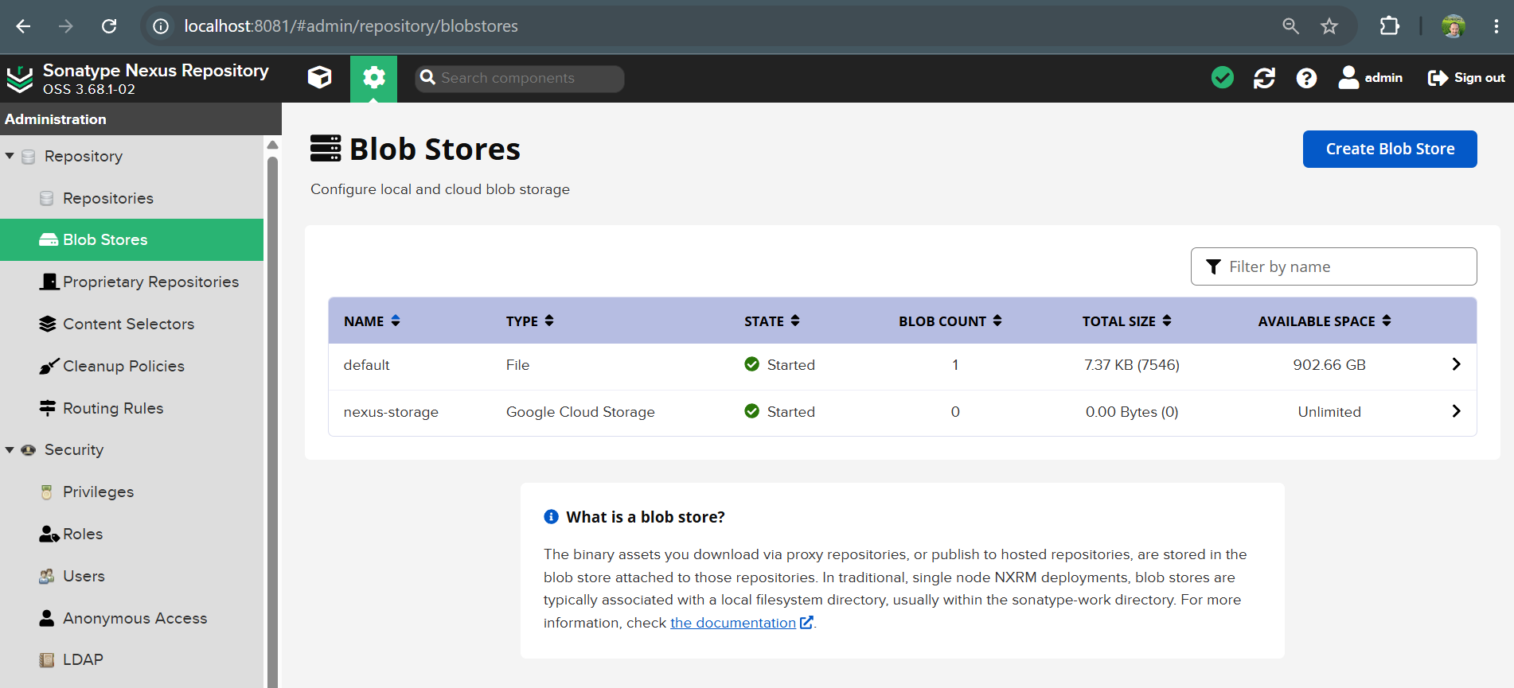
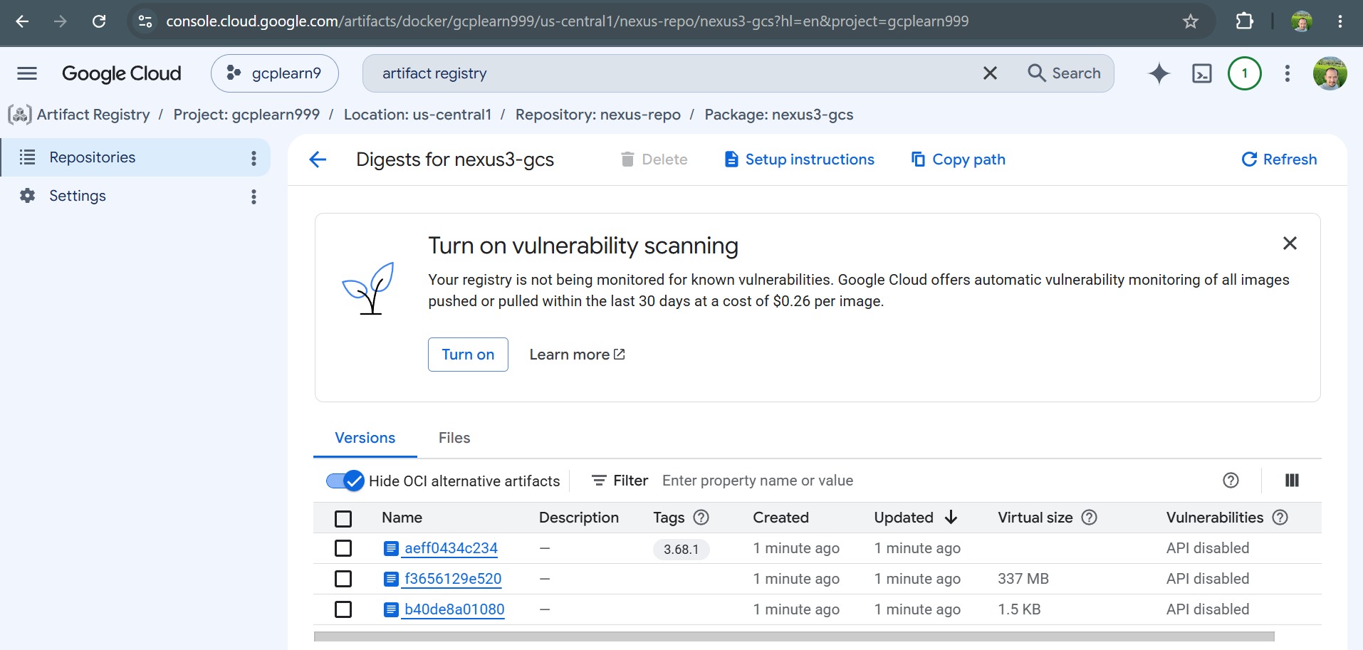

Kubernetes configs

GCP resource creation

Deploy

Continuous integration

